Cells and Microscopes Review Markscheme
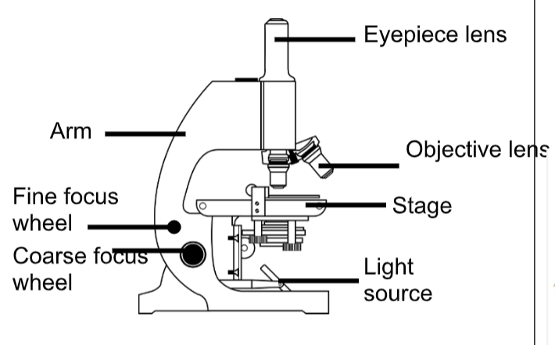

- Describe the steps you would follow to view a cell sample under this microscope.

- Place the specimen/sample on a slide (with a drop of stain and a cover slip) and secure with stage clips
- Set the objective lens to the lowest magnification
- Move the stage up towards the objective lens using the coarse focus wheel (ensuring that the lens does not touch the slide)
- Look through the eyepiece lens and use the coarse focus wheel to slowly bring the sample into focus
- When the image has become clearer, focus further using the fine focus wheel until the image is clear

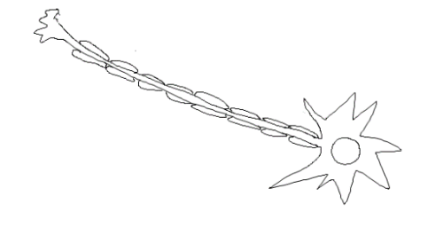
- State the function of each of the specialised cells below and how its structure is adapted for its function:



Neuron (Nerve cell)
Function: send messages/impulses to control the body
Structure: long (axon) and lots of connections to pass messages easily
Sperm cell
Function: to swim to the egg/fertilise the egg
Structure: tail to swim/mitochondria to provide lots of energy

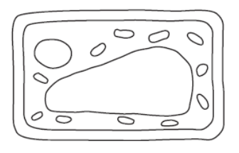
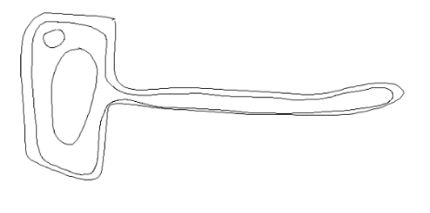

Root hair cell
Function: to absorb water for photosynthesis
Structure: large surface area
Leaf cell
Function: to take in lots of sunlight for photosynthesis
Structure: lots of chloroplasts (containing chlorophyll)

- Write the correct keyword for each definition:

- A group of the same cells working together _____tissue____

- A group of tissues working together for the same function __organ__________

- A group of organs working together for the same function __organ system___

Stretch Activity
- Skeletal system – support and protection of the body, made up of all bones and joints
- Nervous system – transmitting signals throughout the body, controlling movement and responses, made up of brain, spinal cord, neurons, sense organs and muscles
- Circulatory system – supplies body with oxygen, transports hormones and removes waste, made up of heart and blood vessels
- Respiratory system – taking in of oxygen and expulsion of carbon dioxide, primarily focused on lungs
- Digestive system – breakdown of food into smaller components that can be used by the body, mouth, salivary glands, oesophagus, stomach, intestines, liver, gall bladder, pancreas, rectum, anus

